IRIS

Quick Start Guide

Note: This manual will cover the knowledge needed to setup and operate the IRIS acquisition software, ZoirayAcquireLED revision 4. Features and operating procedure may alter with software revision.

2013

Alexander Reddington

OCN Lab

7/23/2013

Table of Contents

Installing Drivers 15

Connect Cables 17

Install IRIS Software 17

Run IRIS Software 18

Welcome to the IRIS software manual. This manual will provide a quick overview of the IRIS hardware and software. Instructions to operate the IRIS software, ZoirayAcquireLED, are included.

**Terms**

**Root name:** File name which will be used to identify the experiment. Files will append keywords and timestamps to this for identification.

**Timestamp:** A 6 digit number which signifies the time which the file was acquired. This is in military time and is set according to the computer's clock. The form is [hh][mm][ss].

**ROI:** Region-of-interest. A full or partial image which contains the data of interest.

**FOV:** Field-of-view. The observable area through the camera's sensor.

**Fitting:** The process of calculating the mass density of the image

**Chapter 1: Getting Started**

Read this chapter to learn how to set up your IRIS instrument.

**WHAT YOU NEED**

To use IRIS, you need:

* A PC computer with Windows XP Home or Professional or earlier
* An approved graphics card with compute capability (CC) 1.3 or higher and atleast 512MB of memory
* The ZoirayAcquireLED software package
* Drivers:
  + QImaging (Camera)
  + National Instruments (DAQ)
  + CUDA Toolkit v5.0
* A firewire connection and cable
* A firewire cable
* A USB connection
* A USB cable

**SETTING UP IRIS**

To set up IRIS:

* Install the drivers
  + May also need to install Microsoft .NET Framework
* Connect the firewire, USB, and power cables
* Install IRIS Software

# Installing Drivers

* Support Videos:

- Vid1 - Setup Camera - Download Driver

- Vid2 - Setup Camera - Installing Driver

- Vid3 - Setup DAQ - Download Driver

- Vid4 - Setup DAQ - Installing Driver

- Vid5 - Setup Camera - Update Driver

Camera Driver: QCamDriver1901.exe

If you do not have the driver, go to <http://www.qimaging.com/support/downloads/legacy_qcamdriver.php>.

1. Open the QCam software. Click Next and follow the instructions.

# Image - QCam Install - 1.png

NI DAQ Driver: NIDAQ960f0.exe

If you do not have the driver, go to <http://joule.ni.com/nidu/cds/view/p/id/3423/lang/en>

1. Open the software. Click Ok.

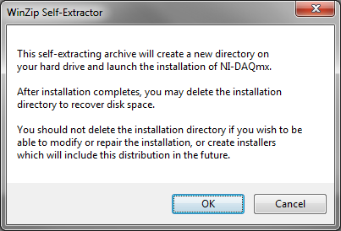

1. Click Unzip.

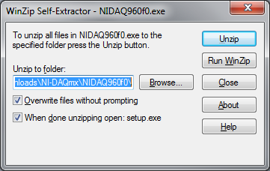

CUDA Toolkit v5.0: _______

If you do not have the driver, go to _____

1. Open the software.

# Connect Cables

1. Connect the firewire cable to the camera and computer

Image - Connect camera.tif

1. Connect the USB cable to the DAQ and computer

Image - Connect DAQ copy.tif

# Install IRIS Software

* Support Videos:

- Vid6 - Setup Software - Extract Software

- Vid7 - Setup DAQ - Verifying Device #

- Vid8 - Setup Software - Set Defaults

1. Extract ZoirayAcquireLED_v4.zip to the folder C:\User_Scratch\LocalTools\ (See "Vid6 - Setup Software - Extract Software")

Image2 - Setup - Unzipping2.tif

Figure 2. Screenshot of zip file extraction. The highlighted region shows the folder is C:\User_Scratch\LocalTools\

1. Setup defaults.txt.

* Do not add or substrate any lines. All lines must end with a semi-colon, ";"
* Verify the correct device number (See "Vid7 - Setup DAQ - Verifying Device #"), camera_mode (camera name), and instrument name. Save the text file when finished.

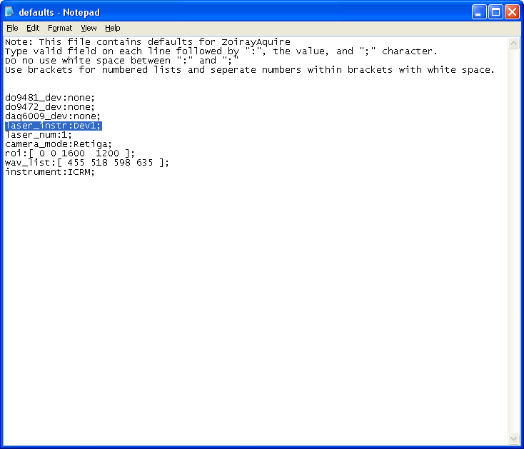

Figure 3. Screenshot of defaults.txt. (See "Vid8 - Setup Software - Set Defaults")

**Chapter 2: Using the software**

* Support Videos:

- Vid9 - Run Software - Startup

- Vid10 - Run Software - Acquire Mirror

- Vid11 - Run Software - Acquire Data

- Vid12 - Run Software - Fit Data

1. Double click ZoirayAcquireLED_v4.exe

* A command prompt will appear. If this is the first time, a few minutes will be needed to extract 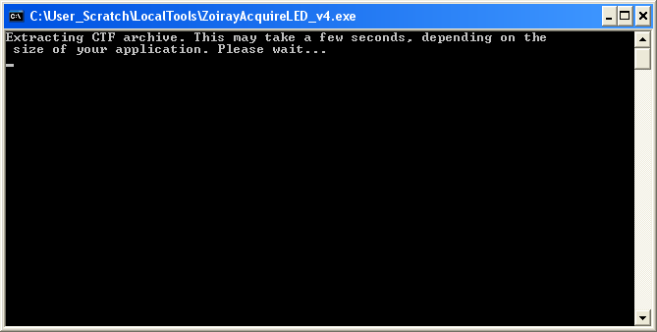

1. Adjust the default values if needed. Hit ok when done.

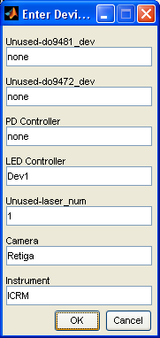

1. Click "Select Save Name". Browse to save folder and set root name

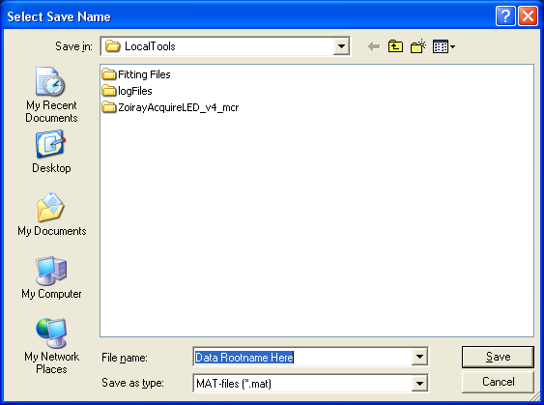

1. Set exposure time

* Place a mirror sample under the microscope and focus using "Live Preview"
* Use Histogram and Sweep Hist to check intensity levels. Intensity should be set between 0.6-0.7

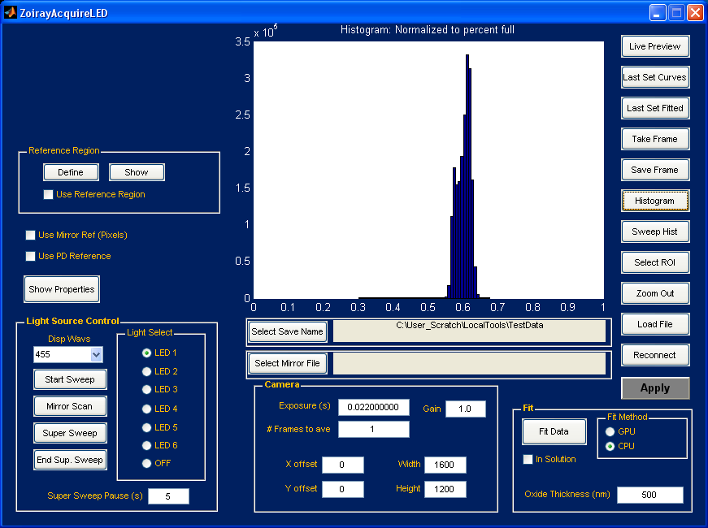

1. Set "# Frames to ave" to 50
2. Acquire a mirror scan

* Place a mirror sample under the microscope and focus using "Live Preview"
* Click "Mirror Scan"

1. Acquire a dataset.

* Place an IRIS sample under the microscope and focus using "Live Preview"

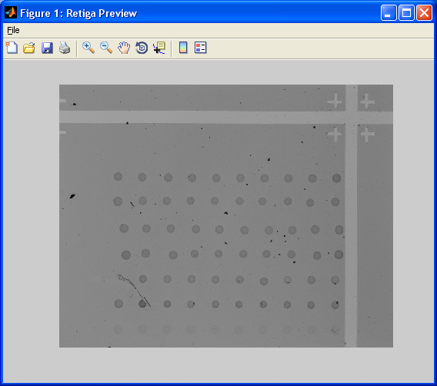

* Check the mirror box
* Define the reference region

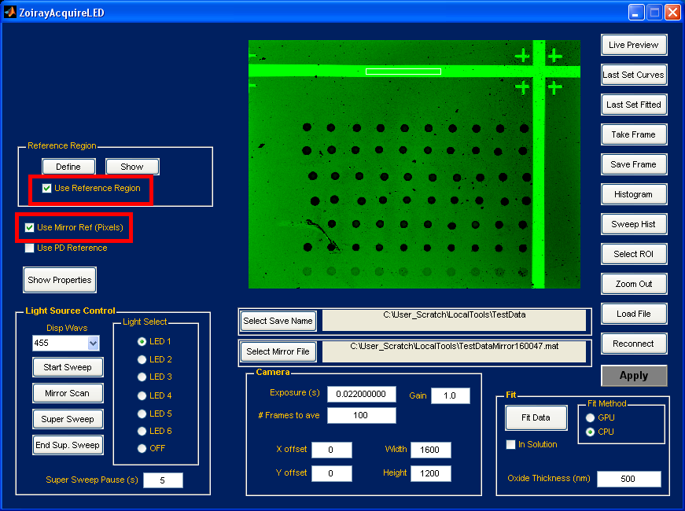

* For a single dataset, click "Start Sweep"
* For continuous datasets, click "Super Sweep". To stop, click "End Sup. Sweep".

1. Fit datasets

* Select "GPU" in the Fit Method panel
* Set the "Oxide Thickness"
* Click "Fit Data". It will fit all unfitted datasets with the "Select Save Name" root name.

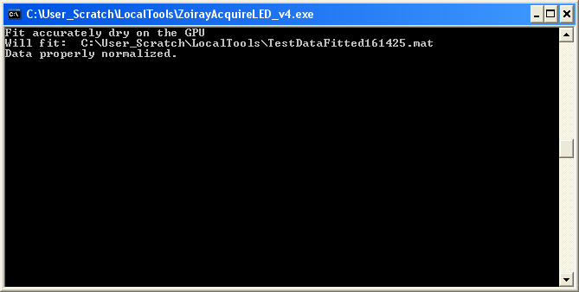

* Looking for the process CaFE_single_complex.exe for verification

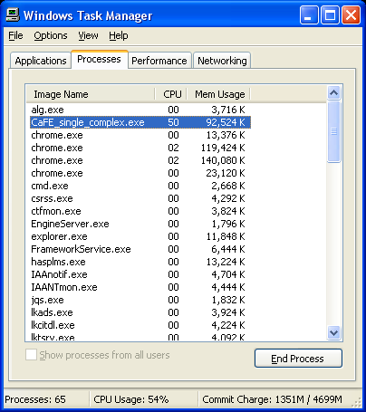

* The elapsed time and saved file path with be reported when finished. The next file with the same root name (if any) will begin fitting next.

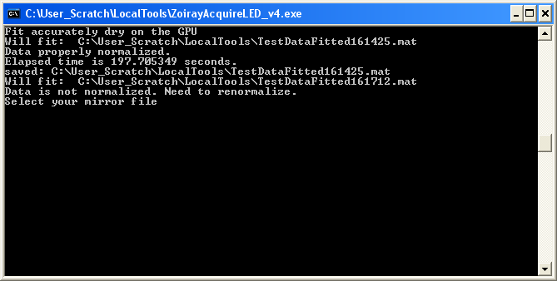

**Chapter 3: Hardware at a Glance**

Read this chapter to learn about IRIS features, requirements, how to use the software, and more.

**OVERVIEW: HARDWARE**

**Instrument copy.tif**

**ACCESSORIES**

The following accessories are include with the IRIS instrument:

Image - DAQ.tif

**National Instruments Data Acquisition (DAQ) Device USB-6009:** Use this to control the LEDs. Connect the P0,P1,P2,P3 ports to the Blue, Green, Yellow, and Red LED control wires, respectively. Plug the USB cable into this to connect into the computer.

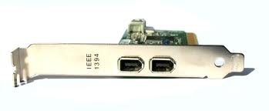

**Firewire Card:** Install this PCI card into your computer. A firewire connection will be required to connect the camera.

***Note:*** Not all firewire cards will work. If the computer already has one, be sure to test if the camera properly connects (See *Connecting the Camera*).

Image - GraphicsCard.tif

**Graphics Card:** Install this card in the computer. A second graphics card in the computer will be used for image processing. Processing images using the rendering graphics card will corrupt the display until the computer is restarted.

usb-cable.tif

**USB A-to-B Cable:** Use this to connect the National Instruments USB-6009 DAQ to your computer for LEDs control.

usb-cable.tif

**Hex Key Set:** These tools will be used for any alignment which may be needed.

**Chapter 4: Software at a Glance**

**OVERVIEW: SOFTWARE**

ZoiracyAcquireLED is the software package required for acquisition of data using IRIS.

Image - GUI Overview copy.tif

**SOFTWARE BUTTONS**

The user interface is littered with buttons allowing for both the new and experience users varying levels of control. Below is a description of the purpose of each button and panel

Normalization Controls

**Define**

Button. This defines the region used for one of the normalizations, the reference region (silicon region).

**Precondition:** A sample is under the microscope. An image is plotted in the main display.

**Operation:** Click "Define". Select two opposite corners of the rectangle (upper left and bottom right or upper right and bottom left). Order does not matter. These points will define the box for the reference region. Be sure this rectangle only contains reference areas.

**Show**

Button. This displays the selected reference region created by "Define"

**Precondition:** "Define" is executed at least once.

**Operation:** Click "Show". Observe the box drawn in the main display. Nothing will appear if "Define" has not been run.

**Use Reference Region**

Check Box. This enables the normalization of the data by the reference region.

**Precondition:** A reference region is specified using "Define"

**Operation:** Select the check box. "Using the reference region" will be displayed on the command prompt. After data is acquired, "Data normalized by reference region" will be displayed before saving.

**Use Mirror Ref**

Check Box. This enables the normalization of the data by the mirror in "Select Mirror File".

**Precondition:** "Mirror scan" must have been completed to create a mirror file. "Select Mirror File" must point to the mirror file.

**Operation:** Select the check box. "Using the mirrorr " will be displayed on the command prompt. After data is acquired, "Data normalized by pixel-by-pixel with mirror" will be displayed before saving.

**Use PD Reference (OPTIONAL)**

Check Box. This enables the recording of photodiode data.

**Precondition:** The system must be equipped an external photodiode (not standard).

**Operation:** Select the check box. "Using the PD reference" will be displayed on the command prompt.

**Show Properties** (NOT USED)

Button. Displays the parameters associated with a dataset's acquisition.

**Precondition:** "Select Save Name" is set

**Operation:** Click the button. The parameters are displays in the command prompt.

Acquisition Controls

**Disp Wavs**

Drop down. Displays the current LED wavelengths.

**Precondition:** None

**Operation:** Select drop down arrow to display the complete wavelength selection for the instrument

**Light Select**

Radio Panel. Changing the selected radio button toggles the LEDs.

**Precondition:** None

**Operation:** Select the LEDs corresponding radio button to manually toggle

**Start Sweep**

Button. Acquires 1 dataset and normalizes if enabled. The data is saved in the "Select Save Name" path with the form "[root name]DataSet[timestamp].mat"

**Precondition:** A sample is placed under the microscope and focused. "Select Save Name" is set. If normalizing, reference region is defined and "Select Mirror" is set.

**Operation:** LEDs will be toggled in series. An averaged image will be acquired for each LED. Normalization will be applied before saving if enabled. The data will be saved in the form "[root name]DataSet[timestamp].mat" for processing.

**Mirror Scan**

Button. Acquires a mirror dataset for normalizing data. The mirror data is saved in the "Select Save Name" path with the form "[root name]Mirror[timestamp].mat"

**Precondition:** A mirror is placed under the microscope and focused.

**Operation:** LEDs will be toggled in series. An averaged image will be acquired for each LED. The data will be saved in the form "[root name]Mirror[timestamp].mat". "Select Mirror" will be automatically set to this file.

**Super Sweep**

Button. Continuously acquires datasets until stopped with a user-specified pause between datasets. The data is saved in the "Select Save Name" path with the form "[root name]DataSet[timestamp].mat"

**Precondition:** A sample is placed under the microscope and focused. "Select Save Name" is set. If normalizing, reference region is defined and "Select Mirror" is set.

**Operation:** LEDs will be toggled in series. An averaged image will be acquired for each LED. Normalization will be applied before saving if enabled. The data will be saved in the form "[root name]DataSet[timestamp].mat" for processing.

**End Sup. Sweep**

Button. Stops super sweep.

**Precondition:** Super sweep is active.

**Operation:** Click "End Sup. Sweep" to end super sweep. If in the middle of acquiring a dataset, acquisition will finish before stopping.

**Super Sweep Pause**

Integer. Specifies the amount of time to pause between super sweep acquisitions.

**Precondition:** Super sweep is not active. "Select Save Name" is set. Normalization controls are set.

**Operation:** Enter an positive integer to set the time paused between acquisitions in seconds.

Select Data

**Select Save Name**

Button. Sets the folder path and root name for saving all files: datasets, fitted, and mirrors

**Precondition:** None

**Operation:** Click "Select Save Name". A browse window will appear. Navigate to the folder where the data should be saved. Specify the root name in File name. Click "Save".



**Select Mirror File**

Button. Sets the folder path and file to be used as the mirror.

**Precondition:** None

**Operation:** Click "Select Mirror File". A browse window will appear. Navigate to the folder where the mirror is located and select it. Click "Open".

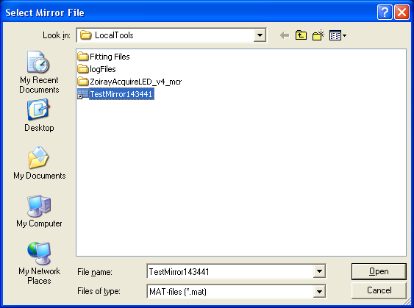

Camera Controls

**Exposure**

Integer. Sets the camera exposure time.

**Precondition:** A mirror is placed under the microscope and focused.

**Operation:** Click "Histogram". Adjust exposure to move histogram between 0.6-0.7. If preview is open, reopen to put changes into effect.

**# Frames to Ave**

Integer. Determines the number of frames to average. This raises the signal-to-noise ratio of the image for accurate measurements. *Only a single composite image is saved.*

**Precondition:** None

**Operation:** When acquiring data, set to at least 50. If viewing the histogram or image, set to 5.

**Gain**

Integer. Determines the electronic gain. Does not affect the signal-to-noise ratio. Best left to 1.

**Precondition:** None

**Operation:** Leave as default.

**X offset**

Integer. Determines the number of pixel to offset the left side of the image on the sensor

**Precondition:** "X offset" and "Width" must not exceed the maximum sensor width (1600).

**Operation:** Set integer to desire value. If preview is open, reopen to put changes into effect.

**Y offset**

Integer. Determines the number of pixel to offset the top of the image on the sensor

**Precondition:** "Y offset" and "Height" must not exceed the maximum sensor height (1200).

**Operation:** Set integer to desire value. If preview is open, reopen to put changes into effect.

**Width**

Integer. Determines the width of the image.

**Precondition:** "X offset" and "Width" must not exceed the maximum sensor width (1600).

**Operation:** Set integer to desire value. If preview is open, reopen to put changes into effect.

**Height**

Integer. Determines the height of the image.

**Precondition:** "Y offset" and "Height" must not exceed the maximum sensor height (1200).

**Operation:** Set integer to desire value. If preview is open, reopen to put changes into effect.

Processing Controls

**Fit Data**

Button. Initiates fitting of the data to calculate the mass density.

**Precondition:** "Select Save Name" is set.

**Operation:** Click "Fit data". All datasets with the root name in the "Select Save Name" folder will be fit in series. If the data is not normalized, a browse window will appear to select the mirror then an image will appear for selecting the reference region.

**Fit Method**

Radio Panel. Changes the method of fitting. CPU is not implemented.

**Precondition:** None

**Operation:** Select the GPU radio button

**In Solution (NOT IMPLEMENTED)**

Check box. Toggle the fitting algorithm between data acquired in air (dry) and in solution (wet).

**Precondition:** None

**Operation:** Toggle the check box.

**Oxide Thickness**

Integer. Initial guess for the fitting algorithm.

**Precondition:** Know the base thickness within approximately ±50nm.

**Operation:** Enter the base thickness.

Setup Controls

**Live Preview**

Button. Open a window containing a video of the sample surface for alignment.

**Precondition:** A sample is placed under the microscope. Exposure time is set.

**Operation:** Click. When finished, close the window.

**Last Set Curves** (NOT USED & NOT IMPLEMENTED)

Button. Displays the quality of the last fit dataset in the main display.

**Precondition:** "Select Save Name" is set. At least one dataset has been fit.

**Operation:** Click. Curves will be displayed in the main display.

**Last Set Fitted** (NOT USED & NOT IMPLEMENTED)

Button. Displays the last image fitted in the main display.

**Precondition:** "Select Save Name" is set. At least one dataset has been fit.

**Operation:** Click. The fitted image will be displayed in the main display.

**Take Frame**

Button. Acquires an averaged image for the current LED illumination and displays it in the main display.

**Precondition:** A sample is place under the microscope.

**Operation:** Click. The image will be displayed, but not saved, once acquired.

**Save Frame**

Button. Acquires an averaged image for the current LED illumination, plots it in the main display, and saves the data.

**Precondition:** A sample is place under the microscope. "Select Save Name" is set.

**Operation:** Click. The image will be acquired, displayed, and saved in the form [root name]Frame[timestamp].mat.

**Histogram**

Button. Acquires an averaged image for the current LED illumination and plots the normalized intensity histogram in the main display. The x-axis is the fill percentage of the camera. For tuning the intensity of the LEDs, set the peak value to 0.6-0.7 when imaging a mirror.

**Precondition:** A sample is placed under the microscope. The LED of interest is selected.

**Operation:** Click. The histogram will be displayed in the main display once finished.



**Sweep Hist**

Button. Acquires an averaged image for each LED in series and plots the normalized intensity histogram one-by-one in the main display. The x-axis is the fill percentage of the camera. For tuning the intensity of the LEDs, set the peak value to 0.6-0.7 when imaging a mirror.

**Precondition:** A sample is placed under the microscope

**Operation:** Click. The histograms will be displayed one-by-one in the order they are taken in the main display.

**Select ROI**

Button. Allows the user to graphically select the image ROI.

**Precondition:** A sample is placed under the microscope. An image is plotted in the main display.

**Operation:** Click. Select two opposite corners of the ROI (upper left and bottom right or upper right and bottom left). Order does not matter. These points will define the FOV for subsequent images. "X offset", "Y offset", "Height", and "Width" are updated automatically.

**Zoom Out**

Button. Allows the user change the ROI back to maximum FOV.

**Precondition:** A sample is placed under the microscope. An image is plotted in the main display.

**Operation:** Click. "X offset" and "Y offset" are set to zero and "Height" and "Width" are set to their maximum value.

**Load File (DO NOT USE)**

Button. Loads the image of a previously acquired dataset or fitted file.

**Precondition:** A dataset or fitted file exists on the computer.

**Operation:** A browse window will appear. Navigate to the folder containing the file of interest. Select the file. The image will be displayed in the main display.

**Reconnect**

Button. Reconnects the hardware in the case of a system crash or a hardware reset without resetting the software.

**Precondition:** Hardware is connected and powered on.

**Operation:** Click.

**Chapter X: Troubleshooting Issues**

This section will continue to be populated as errors are encountered.

**Q. I defined a rectangle which was not right and tried again. There are now two rectangles. Which one is correct?**

**A.** The rectangle which was selected right is being used. To verify, acquire another image using "Take Frame", which will clear all rectangles, then use "Show"

**Q. I forgot to check "Use Reference Region" and "Use Mirror Ref (Pixels)". Do I need to take the data again?**

**A.** If you forgot both check boxes, you will be prompted to select the mirror and reference region after pressing "Fit Data". If you forgot one of the two check boxes, you will need to retake the data.

**Q. The timestamp doesn't include day. Could I end up overwriting my own data if taken on different days?**

**A.** This is improbable. Datasets taken on different days can have similar timestamps if accurate to the second, but root names and folders are typically different.

**Q. The preview is open but the image doesn't appear to be changing?**

**A.** If another operation which uses the camera is executed while preview is open (take frame, start sweep, etc), the live feed is disconnected. Close the window and reopen preview to reconnect.